Project Development Phase
Performance Test

Date | 30 September 2026
Team ID | MKU201Team66ab4dee00fc666a751b56cd7
Project Name | Script-Controlled ACL – Restrict Record Access Based on Field Value
Maximum Marks

Model Performance Testing:
Project team shall fill the following information in model performance testing template.
S.No. | Parameter | Screenshot / Values
 | Data Rendered | Institution Details list (u_institution_details) rendered in ServiceNow with records for Branch EEE, ECE and CSE (Admin view).  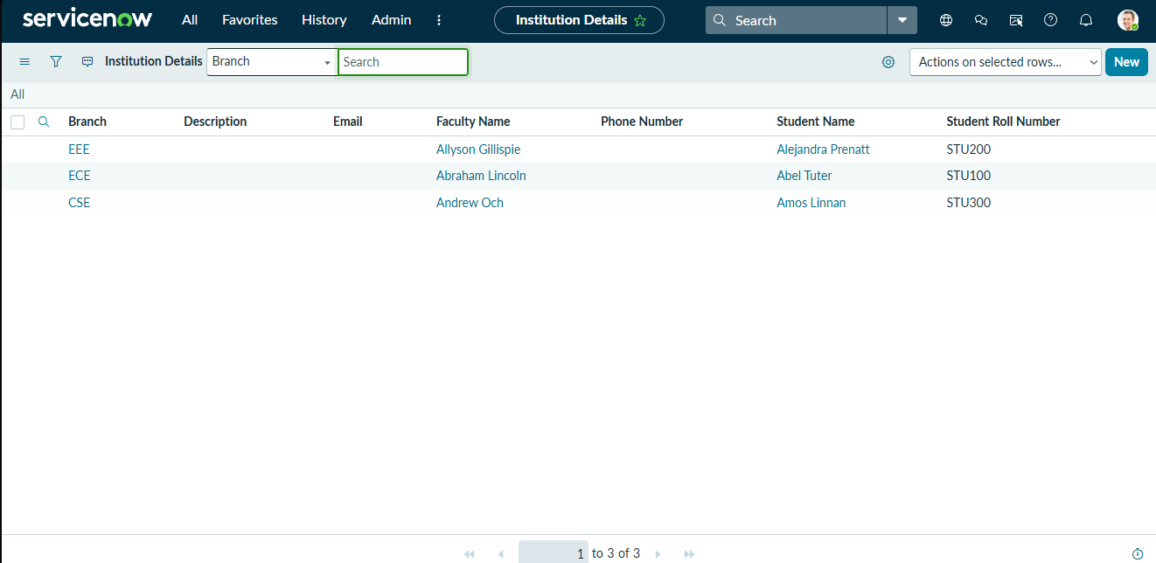
 | Data Preprocessing | Custom table Institution Details (u_institution_details) created with fields Student Roll Number, Student Name, Faculty Name, Branch (ECE, EEE, CSE), Email, Phone Number and Description; EEE User and roles bb1–bb4 created.  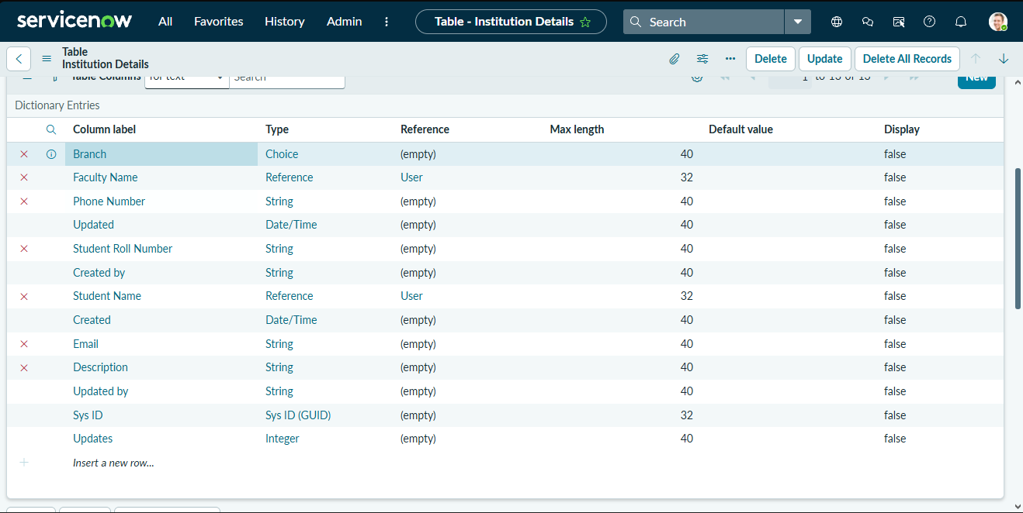
3. | Utilization of Filters | Data condition “Branch is EEE” applied on the Read ACL, so users with the bb1 role see only EEE branch records; Admin sees all records.  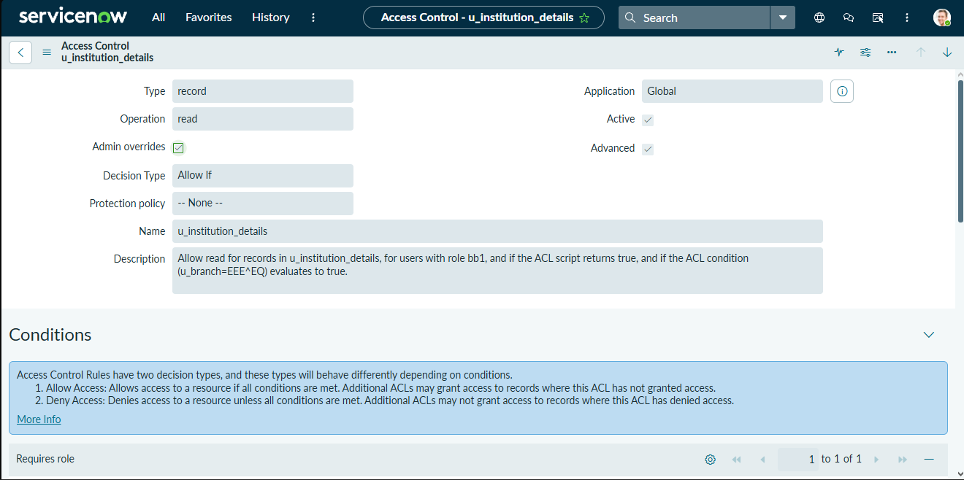
4. | Calculation fields Used | Not applicable – no Tableau calculation fields are used. Access logic is implemented in the ACL script: gs.hasRole('admin') → true; gs.hasRole('bb1') → true; all others → false.
5. | Dashboard design | No of Visualizations / Graphs - 0 (Not applicable – records are presented through the ServiceNow list view of u_institution_details, not a dashboard)
6 | Story Design | No of Visualizations / Graphs - 0 (Not applicable – no Tableau story is used)

